PAX meeting notes August 21-22, 2002

Harold Roussell from Photonics Systems Inc (PSI) visited August 21-22 to discuss the post-amp optical transmitter (PAX). Some introductory material was presented in the regular Wed meeting on the PAM and fiber link. The meeting continued afterwards and into Thurs to further address the f/o.

PSI will build the optical transmitter (OTX). Each PAX has two OTX’s. One goal was to establish this interface. Packaging was also addressed. PSI is measuring and setting up the laser bias, TEC, and Vmod control that are on the Otx boards.

The NEC electro-absorption modulator (NX856OLJ-CC) has slightly superior performance for the same cost and is the unit of choice, with the Fujitsu unit as backup.
PSI will purchase the next set of link components using the NEC in the demo for 10-25-02 if delivery is ok.

The OTX is an open stand-alone card and has the following potential interfaces/power requirements:

1. RF in
The post-amp module (PAM) provides the OTX with RF power on GPO connector. The PAM also has a bias T to provide V_{m} on the coax. PSI will provide the Vm voltage to be feed to the bias tee on the PAM board

2. FO out
The OTX has an FC-APC pigtail with optical power. UCB will get more information on the type of connector the failed in the field and any other information about the cleaning procedure that was used.

3. V_{m} bias
The OTX will provide the PAM the V_{m} bias, which is then fed back via the RF coax. The OTX will derive this from -5 V input. PSI will

4. laser bias
The laser bias is 5 V. PSI will build up this part using Optical feed back which is the way NEC is recommending that we use.

5. TEC
The EAM TEC will regulate against the roughly +/-3degC temperature swings of the PAX using 5 V. The laser will require roughly 22degC. PSI will test for the power supply needs to be sent back to USB.

6. monitor/command
None.

In terms of connectors, each OTX has GPO, FC-APC pigtail, and 4 power leads: -5, GND, +5 and V_{m}. There will likely not be a connector. The OTX will have RF chokes for power on-board.

Figure 1 shows a rough schematic of the PAX. The larger cavity is controlled to about +/-3degC against the outside world by a bigger TEC (Jack was volunteered to design this, since he was in Europe at the time.) The “foyer” in the back allows the connectors to be protected yet easily accessible to disconnect the unit. The design for the fiber connector feed thru will be a small slot to lay the fiber into and RTV up for shielding.

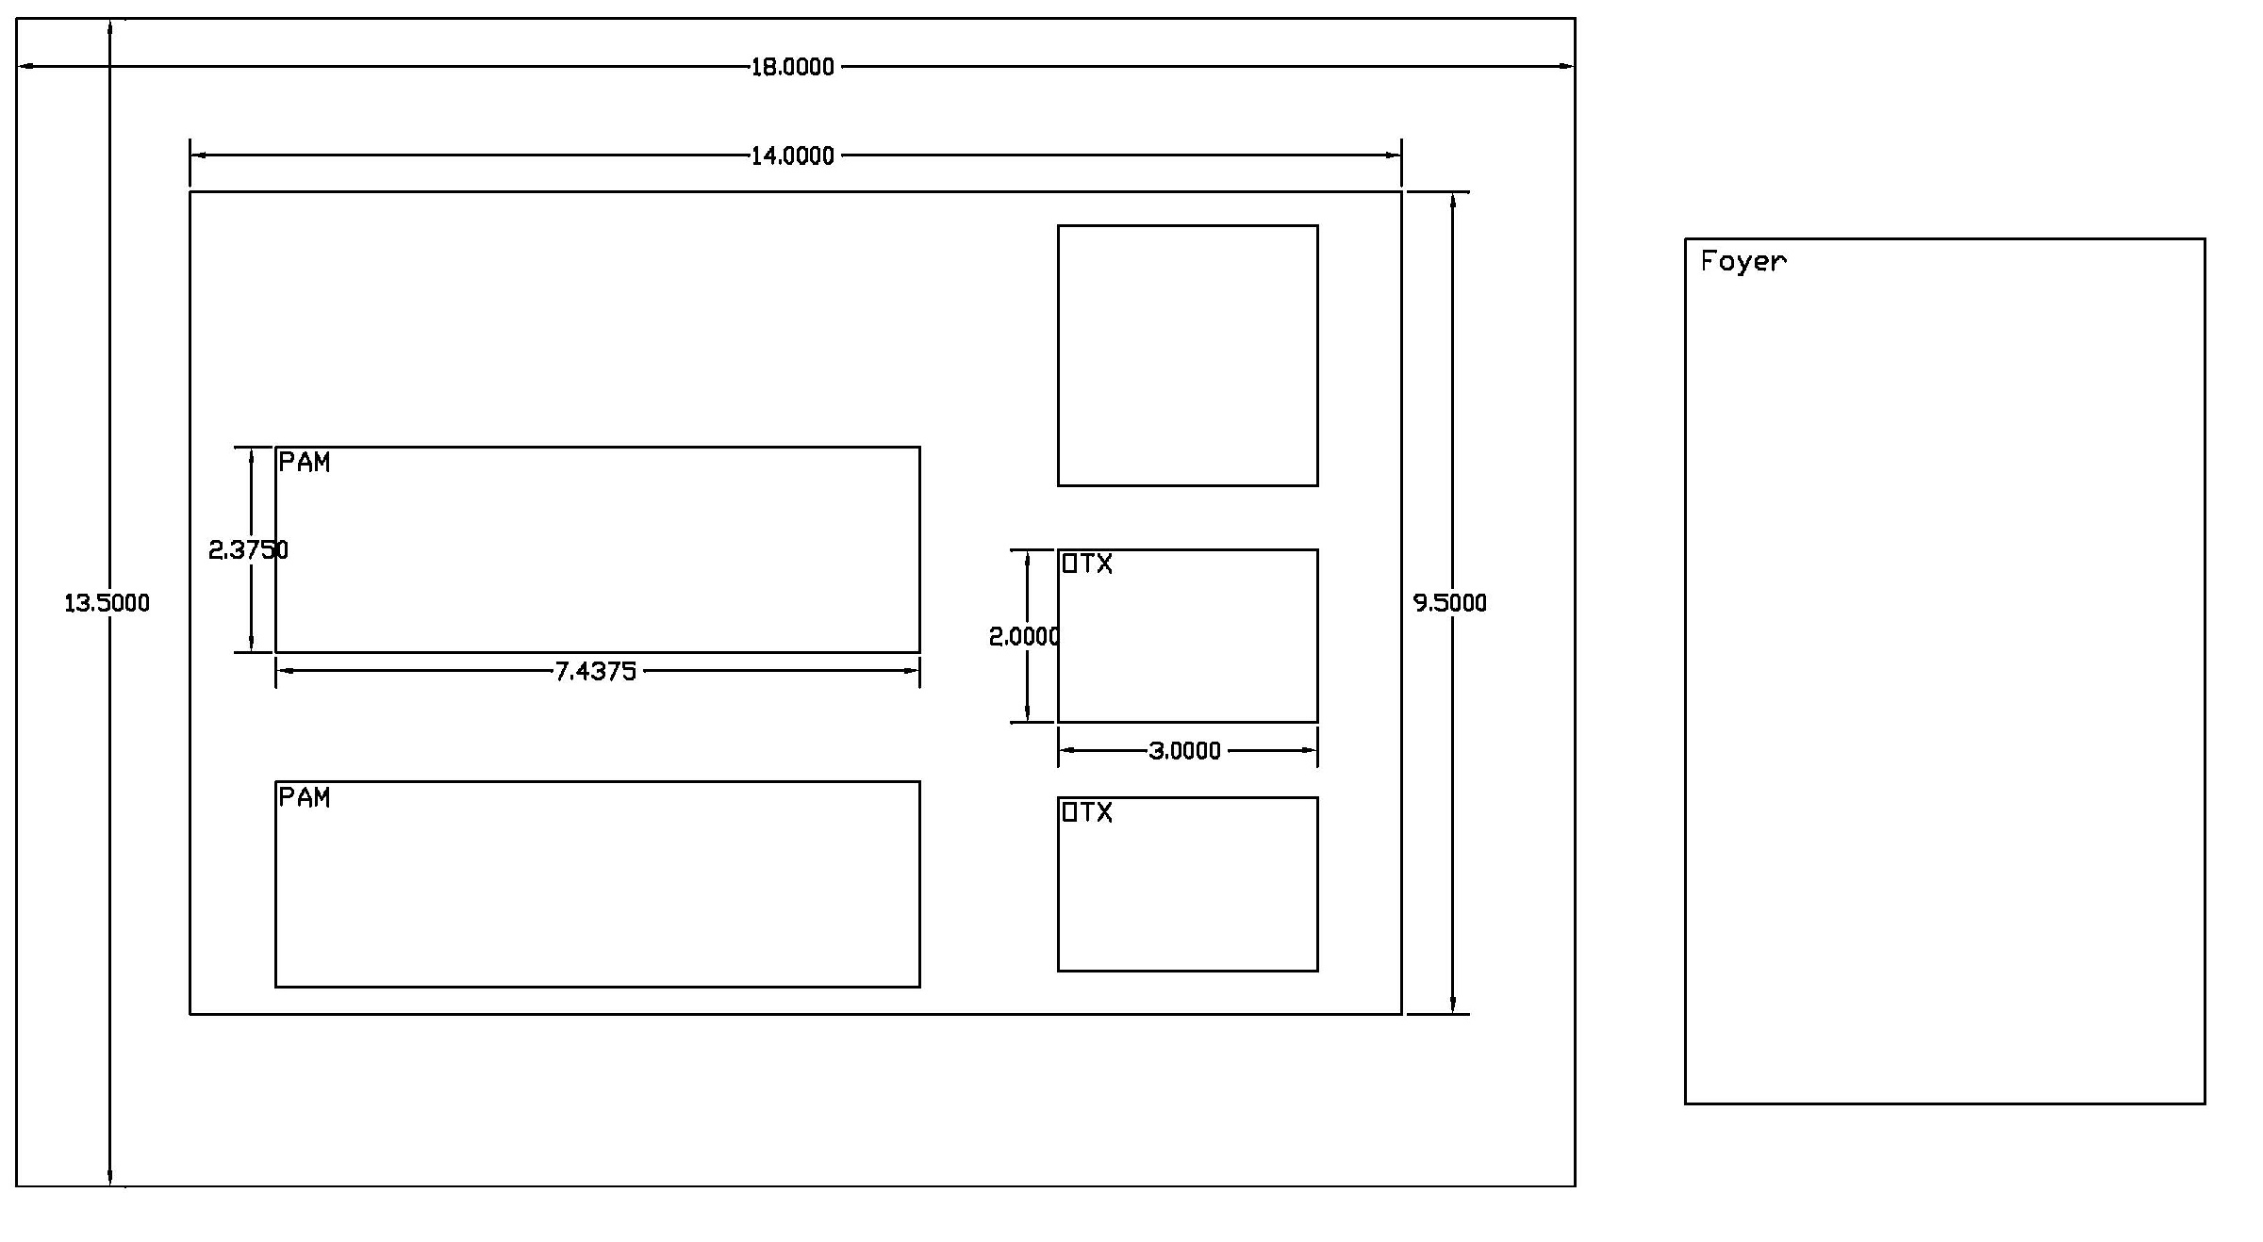
Figure 1

We need to measure the delta-T, delta-V performance of the PAM.

The PAM and RFCB will both use 8mil RO4003 substrate.

We will (have) provided a 50 ohm connectorized microstrip on RO4003 to PSI to test the Discovery diode without the K-connector (sliding Wiltron). PSI will perform this test and pass this information on to Seti..

The microcontroller PIC is +5 volts that will be RF-boxed in the PAX. It communicates via plastic fiber

Thermopads (thermally compensating attenuators) may be used on the PAM to obviate the need to further thermally regulate the PAM.

Doug will incorporate a Zener on the Vm input to protect against a big burn-out and a shunt diode (maybe two) on the PAM output to protect the modulator part of the EAM.

Matt Dexter has brought up that the SMA has problems with the E2000 connectors getting contaminated, even if left undisturbed. John Test at CfA is the engineer with whom to follow up. Based on this we will use FC-APC connectors in the field and E2000 in the electronics bldg. Fortunately we only have a max of 4 (probably 3) pairs of mating connectors. PSI is talking to Diamond USA Inc. for reliability reports and cleaning procedures that they recommend.

PSI will measure the delta-T, delta-V characteristics of the detector.

To control the EAM TEC, we will use a linear unit from HyTech. PSI will order and build up and test each of the boards.

The “big” TEC may be controllable from the alidade. We need to decide where to put it.

Schedule

Three milestones are relevant:

PTA “ver 2.2” – October 25, 2002 => RF back to lab over f/o link.
Minimum of 4 OTX (single-pol on 2 antenna, dual-pol on 1 antenna)
Minimum of 3 “ORX” back in lab (connectorized Discovery photodiodes)
Minimum of 7 PAM (4 at antennas and 3 in lab)

PTA – December 31, 2002 => 6 full links back to lab through cable wrap
Minimum of 6 full links, two spares are desirable.

Milestone – April 1, 2003 => Fully functional tested PTA

Decisions
The NEC-EAM is the first choice, Fujitsu is backup
Use HyTech linear controller for EAM TEC
The OTX is not shielded within PAX
The OTX provides Vm to us, which we send back on bias-T
FC-APC in the field, E2000 in the lab
The OTX is provided with -5,GND, 5 – RF chokes are placed on-board
The OTX provides Vm
No connector, solder connections to posts

Action Items
PSI will get 8 NEC’s and 9 Discovery detectors and the EAM controllers
Doug will measure delta-T, delta-V performance of the PAM
PSI will measure delta-T, delta-V performance of the detector + 5 c
PSI will provide OTX and detector footprints
PSI will test detector performance with sliding contact
PSI will provide S11 data on EAM and send out demo setup to interface with PAM
PSI will measure delta-T, delta-V performance of the EAM and report the voltage and current values.
PSI will build up links for the 2.2 review

Ed Fields comments
Integrate PAX into PIC and TEC
Weatherproof packaging
Connectors accessible and protected
Mounting
TEC design

